5.62: a) The most direct way to do part (a) is to consider the blocks as a unit, with total weight 4.80 N. Then the normal force between block B and the lower surface is 4.80 N, and the friction force that must be overcome by the force F is to three figures. b) The normal force between block B and the lower surface is still 4.80 N, but since block A is moving relative to block B, there is a friction force between the blocks, of magnitude 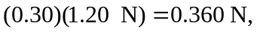 so the total friction force that the force F must overcome is . (An extra figure was kept in these calculations for clarity.)

